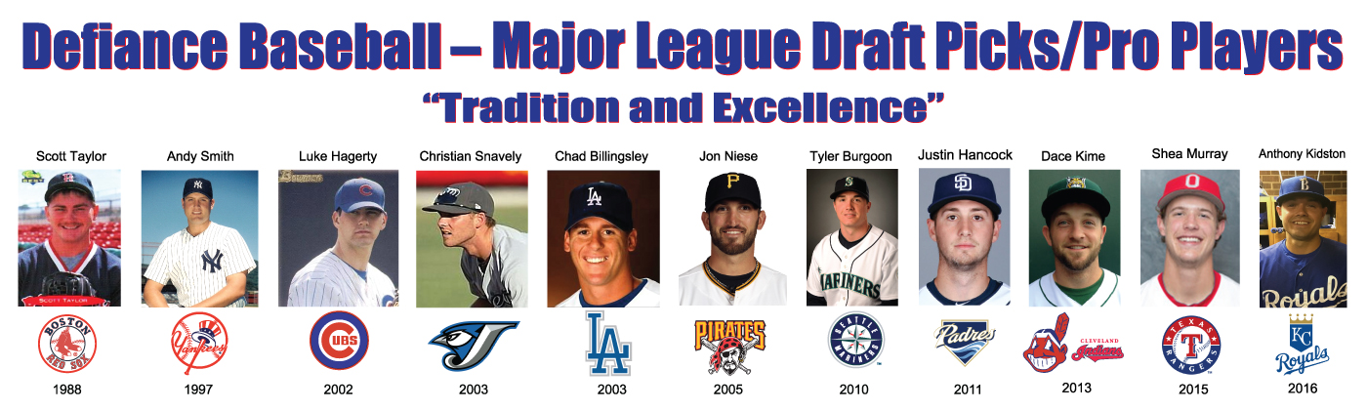
January, 19

To Whom It May Concern:

As winter begins to fade the Defiance High School Baseball & Softball teams are preparing for the upcoming spring season. Traditionally successful, we are looking forward to the 2019 campaign. Part of our success can be attributed to our ability to purchase needed equipment for the spring and summer programs. In order to do that, we need to generate additional funds beyond that which we receive through the school. In the past you have been very supportive of our efforts to field outstanding teams and develop quality future members of society. We are asking that you continue to support our programs and our players through our “Sign Program.”
In the past you have been a generous supporter of our efforts and we would ask that you continue to support our programs by renewing your sign advertisement. Last year 55 companies advertised their business on our outfield fence during the spring and summer seasons. We look forward to your continued support and thank you in advance for your renewal.
Renewal rates are as follows:
1 year renewal- $225.00
2 year renewal- $400.00
3 year renewal- $550.00
4 year renewal- $675.00
If you are interested in changing your advertisement it can be done for $350.00 that includes the cost of the sign and placement for one year.
Please return your order to: Tom Held, Defiance High School Athletic Department, 1755 Palmer Drive, Defiance, Ohio 43512
If you have any questions please feel free to contact Tom Held at 419-784-2777.

Thank you,

Tom Held,
Defiance Baseball

